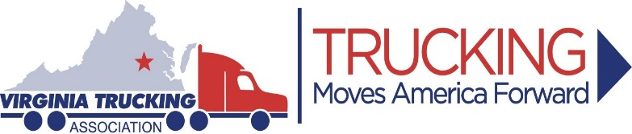
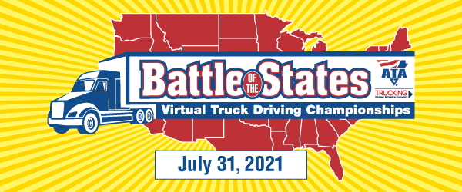

2021 Virginia Registration
The Virginia Trucking Association (VTA) will host this year’s Battle of the States virtual knowledge competition on July 31, 7:00 pm. Drivers will have the opportunity to participate in the state competition for cash prizes and qualify to compete in the National Battle of the States: Virtual Truck Driving Grand Championship. Deadline to enter is July 16, 2021 and is limited to first 100 drivers to register. So get your registration in today!
The trivia contest will be based on Facts for Drivers, federal and state laws, state trucking history and culture. The 10 highest scorers will advance to the National Battle of the States August 14 to compete for National Grand Champion and an opportunity to win great prizes.
The participation fee for the Virginia competition is $20.
Contestant’s Name: _______________________________________________________________________
Employer: _______________________________________________________________________________
Home Address: ___________________________________________________________________________
City: __________________________________ State:_______________ Zip:__________________________
Cell Phone: ______________________________________________________________________________
Email: __________________________________________________________________________________
I certify that I have continuously worked as a truck/step van driver, driven and performed the regular duties and have been accident free since August 23, 2020.
Contestant Signature: ______________________________________________________________________
Payment Information
Please process the below credit card for my $20 registration fee for the VTA Battle of the States.
Credit Card # _____________________________________________________________________________
Exp Date: ___________________________________________ CVC: ______________________________
Prizes for top ten drivers:
1st $1,000 2nd $500 3rd $250 4th $100 5th $100
6th $50 7th $50 8th $50 9th $50 10th $50

To complete registration, please submit this form to Robyn Bolton at rbolton@vatrucking.org or mail to the Virginia Trucking Association, 4821 Bethlehem Rd, Suite 101, Richmond, VA 23230.
Deadline to register is July 16,2021

