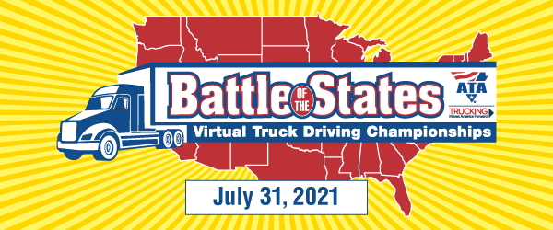

Virginia Battle of the States Sponsorship Opportunities
Battle of the States – Title Sponsor - $2,000.00
Become the Title Sponsor for the “Battle of the States Presented by {Company Name}”. Gain recognition for your support of safety, trucking and the drivers. Your company name and logo will be recognized throughout the Kahoot! Program and all communications for the Battle of the States. (1 available)
Battle of the States – Platinum Sponsor - $1,500.00
Show your support for the best drivers in the industry and promote your company by sponsoring one of the question sections during the Battle of the States. You will get a dedicated Kahoot! Slide listing company name and logo. Also your company will be recognized in all communications for the Battle of the States. (3 available)
Battle of the States – Gold Sponsor -$1,000.00
Become a gold sponsor and sponsor a State Level Question that your company can summit or choose a state level question already submitted. Your company name and logo will be listed on the Kahoot! Slide for that question and your company will be recognized in all communications for the Battle of the States.
Battle of the States – Silver Sponsor - $500.00
As a silver sponsor your company will be listed on a dedicated Kahoot! Slide and recognized in all communications for the Battle of the States.
Battle of the States – Bronze - $250.00
Become a bronze sponsor and your company will be listed on Kahoot! And recognized in communications for the Battle of the States.
In-Kind Prize Sponsor
Recognize the winners of the Battle of the States and get your product in the hands of professional drivers. Winners will be sent a prize package of in-kind sponsored items. Your company will be recognized on Kahoot! and communications about the Battle of the States.
To reserve your sponsorship or if you have any questions, please contact: Robyn Bolton: 804-355-5371 or rbolton@vatrucking.org

Check for $________ is enclosed – Please make checks payable to “Virginia Trucking Association”
In-Kind Prize Description: ________________________________________________________________________
Company Name: __________________________________ Contact Person: ______________________________
Email Address: ____________________________________
To Pay By Credit Card:
Credit Card# ______________________________________ Expiration Date:_______________________________
Name on Card: ____________________________________ Security Code:________________________________
Mailing Address on Card:_________________________________________________________________________

