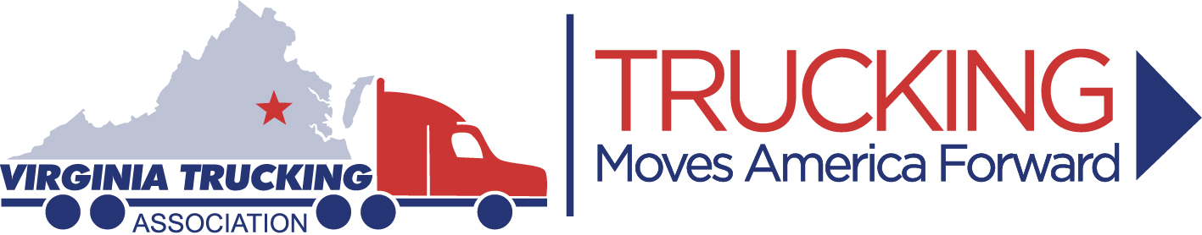

2018 VIRGINIA TRUCK DRIVING CHAMPIONSHIPS

SPONSORSHIP OPTIONS

Platinum/Main Sponsor - $1,000.00

Front cover recognition in the TDC program, along with being named VTATDC main sponsor. Your Company logo will be displayed on TDC banner located above the announcers stand, along with company and main sponsor recognition on sponsorship sign display inside the event tent during the banquet/cookout and the awards presentation, as well as recognition during the event.

Gold Sponsor - $500.00

Rear cover recognition in the TDC program, company logo will be displayed on sign located on the obstacle course during the event, along with company recognition on sponsorship sign on display inside the event tent during the banquet/cookout and the awards presentation, as well as recognition during the event.

Silver Sponsor - $250.00

Inside program recognition in the TDC program, company recognition on sponsorship sign displayed inside the event tent during the banquet/cookout and the awards presentation, as well as recognition during the event.

Bronze Sponsor - $100.00

Inside program recognition in the TDC program, along with company recognition during the event.

Any questions on sponsorship, please contact Robyn Bolton at 804-355-5371.

Please mail to: Virginia Trucking Association or Fax to: 804-358-1374
4821 Bethlehem Road, Suite 101
Richmond, VA 23230

We pledge: $____________ As a sponsor of the 2018 Virginia Truck Driving Championships.

_____Enclosed is our check payable to “Virginia Trucking Association” or _____Please bill us.

Company__________________________________________________________________

Contact Person:_____________________________ Phone:____________________________

Address: ___________________________________ City, State, Zip: _____________________

Email Address: ________________________________________________________________

To Pay By Credit Card:
Credit Card # |  |  | Expiration Date:
Name on Card: |  |  | Security Code:

